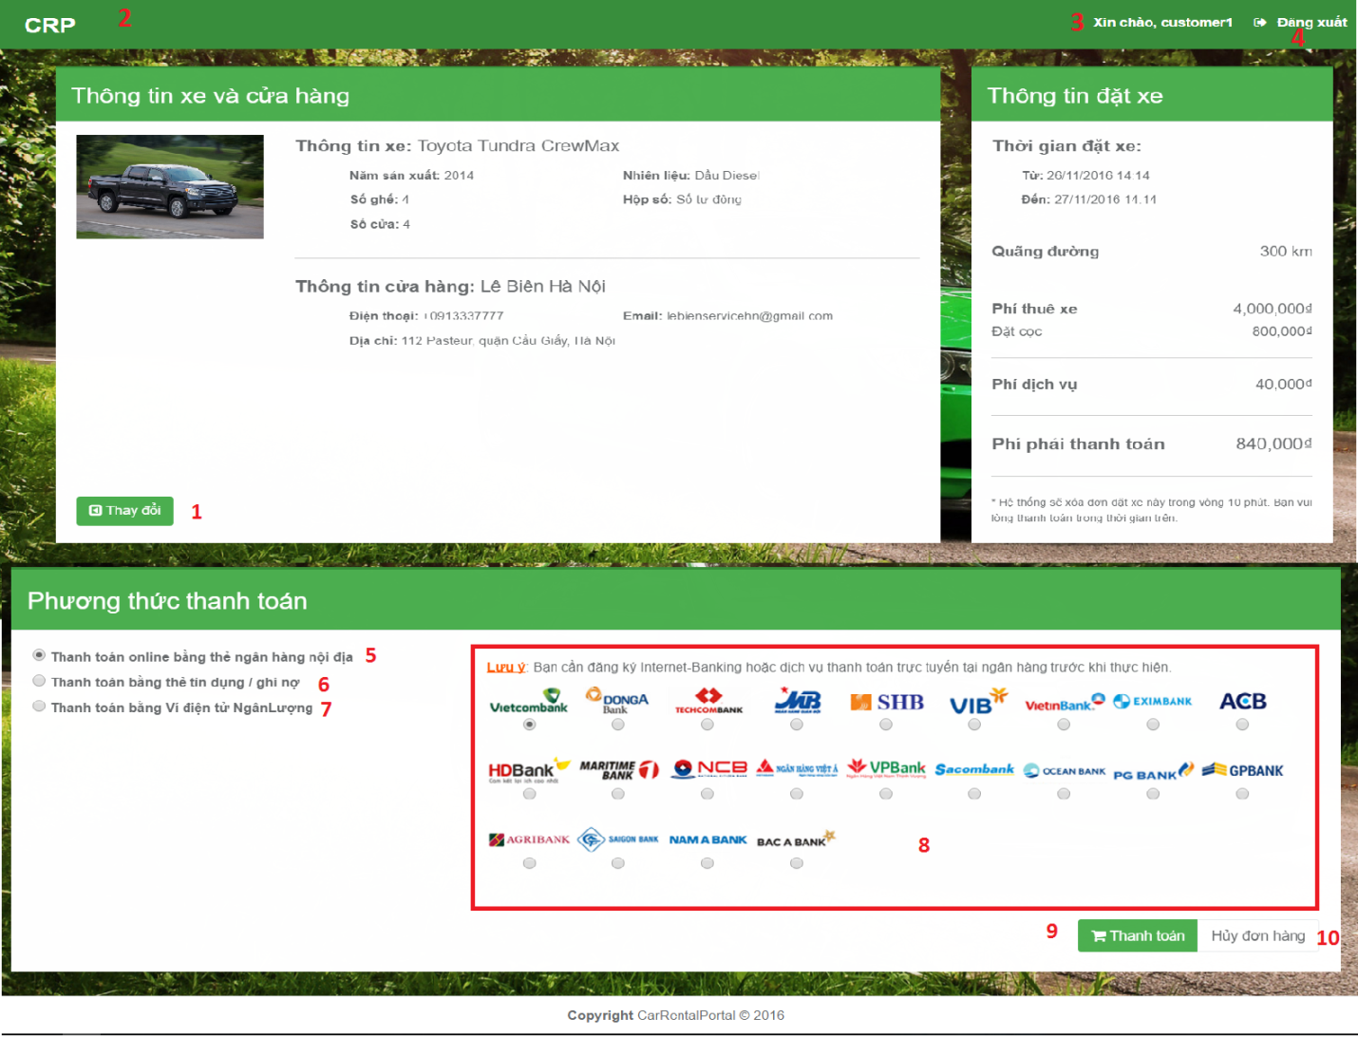

**Fields**:

|  |  |  |  |  |  |  |  |
| --- | --- | --- | --- | --- | --- | --- | --- |
| No. | Field name | Description | Read only | Mandatory | Control type | Data type | Length |
| 8 | Name of Bank | Allow user choose bank which want to payment. | No | Yes | Area radio button | String | N/A |

**Buttons/Hyperlinks:**

|  |  |  |  |  |
| --- | --- | --- | --- | --- |
| No. | Function | Description | Validation | Outcome |
| 1 | Change booking’s information | Click “Thay đổi” button to back vehicle’s information. | N/A | Redirect to view vehicle’s information page. |
| 2 | Redirect to homepage | Click “CRP” icon to redirect to homepage. | N/A | Redirect to homepage. |
| 3 | Redirect to manager personal information | Click “Xin chào” to come manage personal information | N/A | Redirect to manage personal information page. |
| 4 | Log out | Click “Đăng xuất” button to delete session and redirect to homepage. | N/A | Delete session then redirect to homepage. |
| 5 | Online payment type | Choose radio button belong to online payment. | N/A | Show banks for online payment. |
| 6 | Credit card payment type | Choose radio button belong to credit card payment. | N/A | Show banks for credit card payment. |
| 7 | Digital wallet payment type | Choose radio button belong to digital wallet payment. | N/A | Show banks for credit digital wallet payment. |
| 9 | Pay | Click “Pay” to redirect “Ngân lượng” page. | N/A | Redirect to “Ngân lượng” website. |
| 10 | Cancel payment | Click “Hủy đơn hàng” to cancel payment. | N/A | Redirect to “Homepage”. |